Tractor Comparison

Case IH Magnum 215 (2010) vs. Case IH Magnum 250 AFS Connect (2024)

Group 8, Group members: : Idrissa Dembele, Pili Fonua, Evan Warren

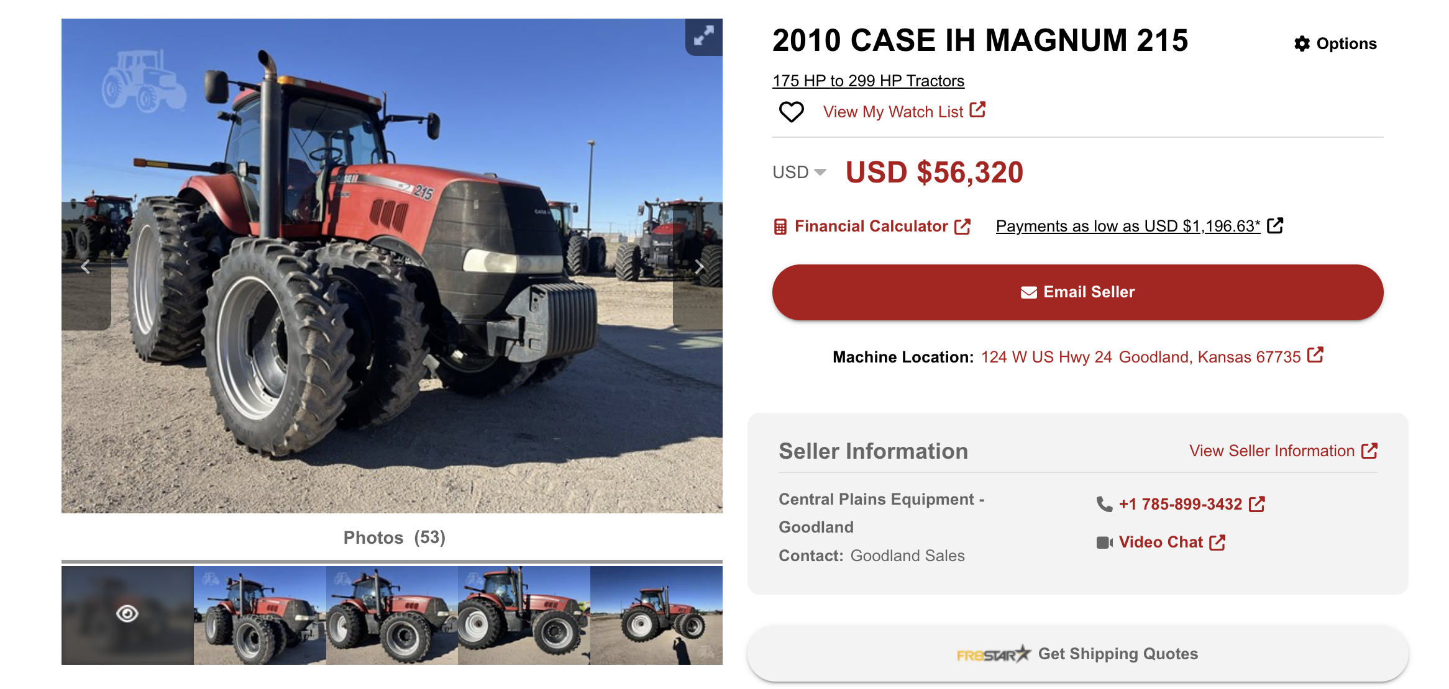

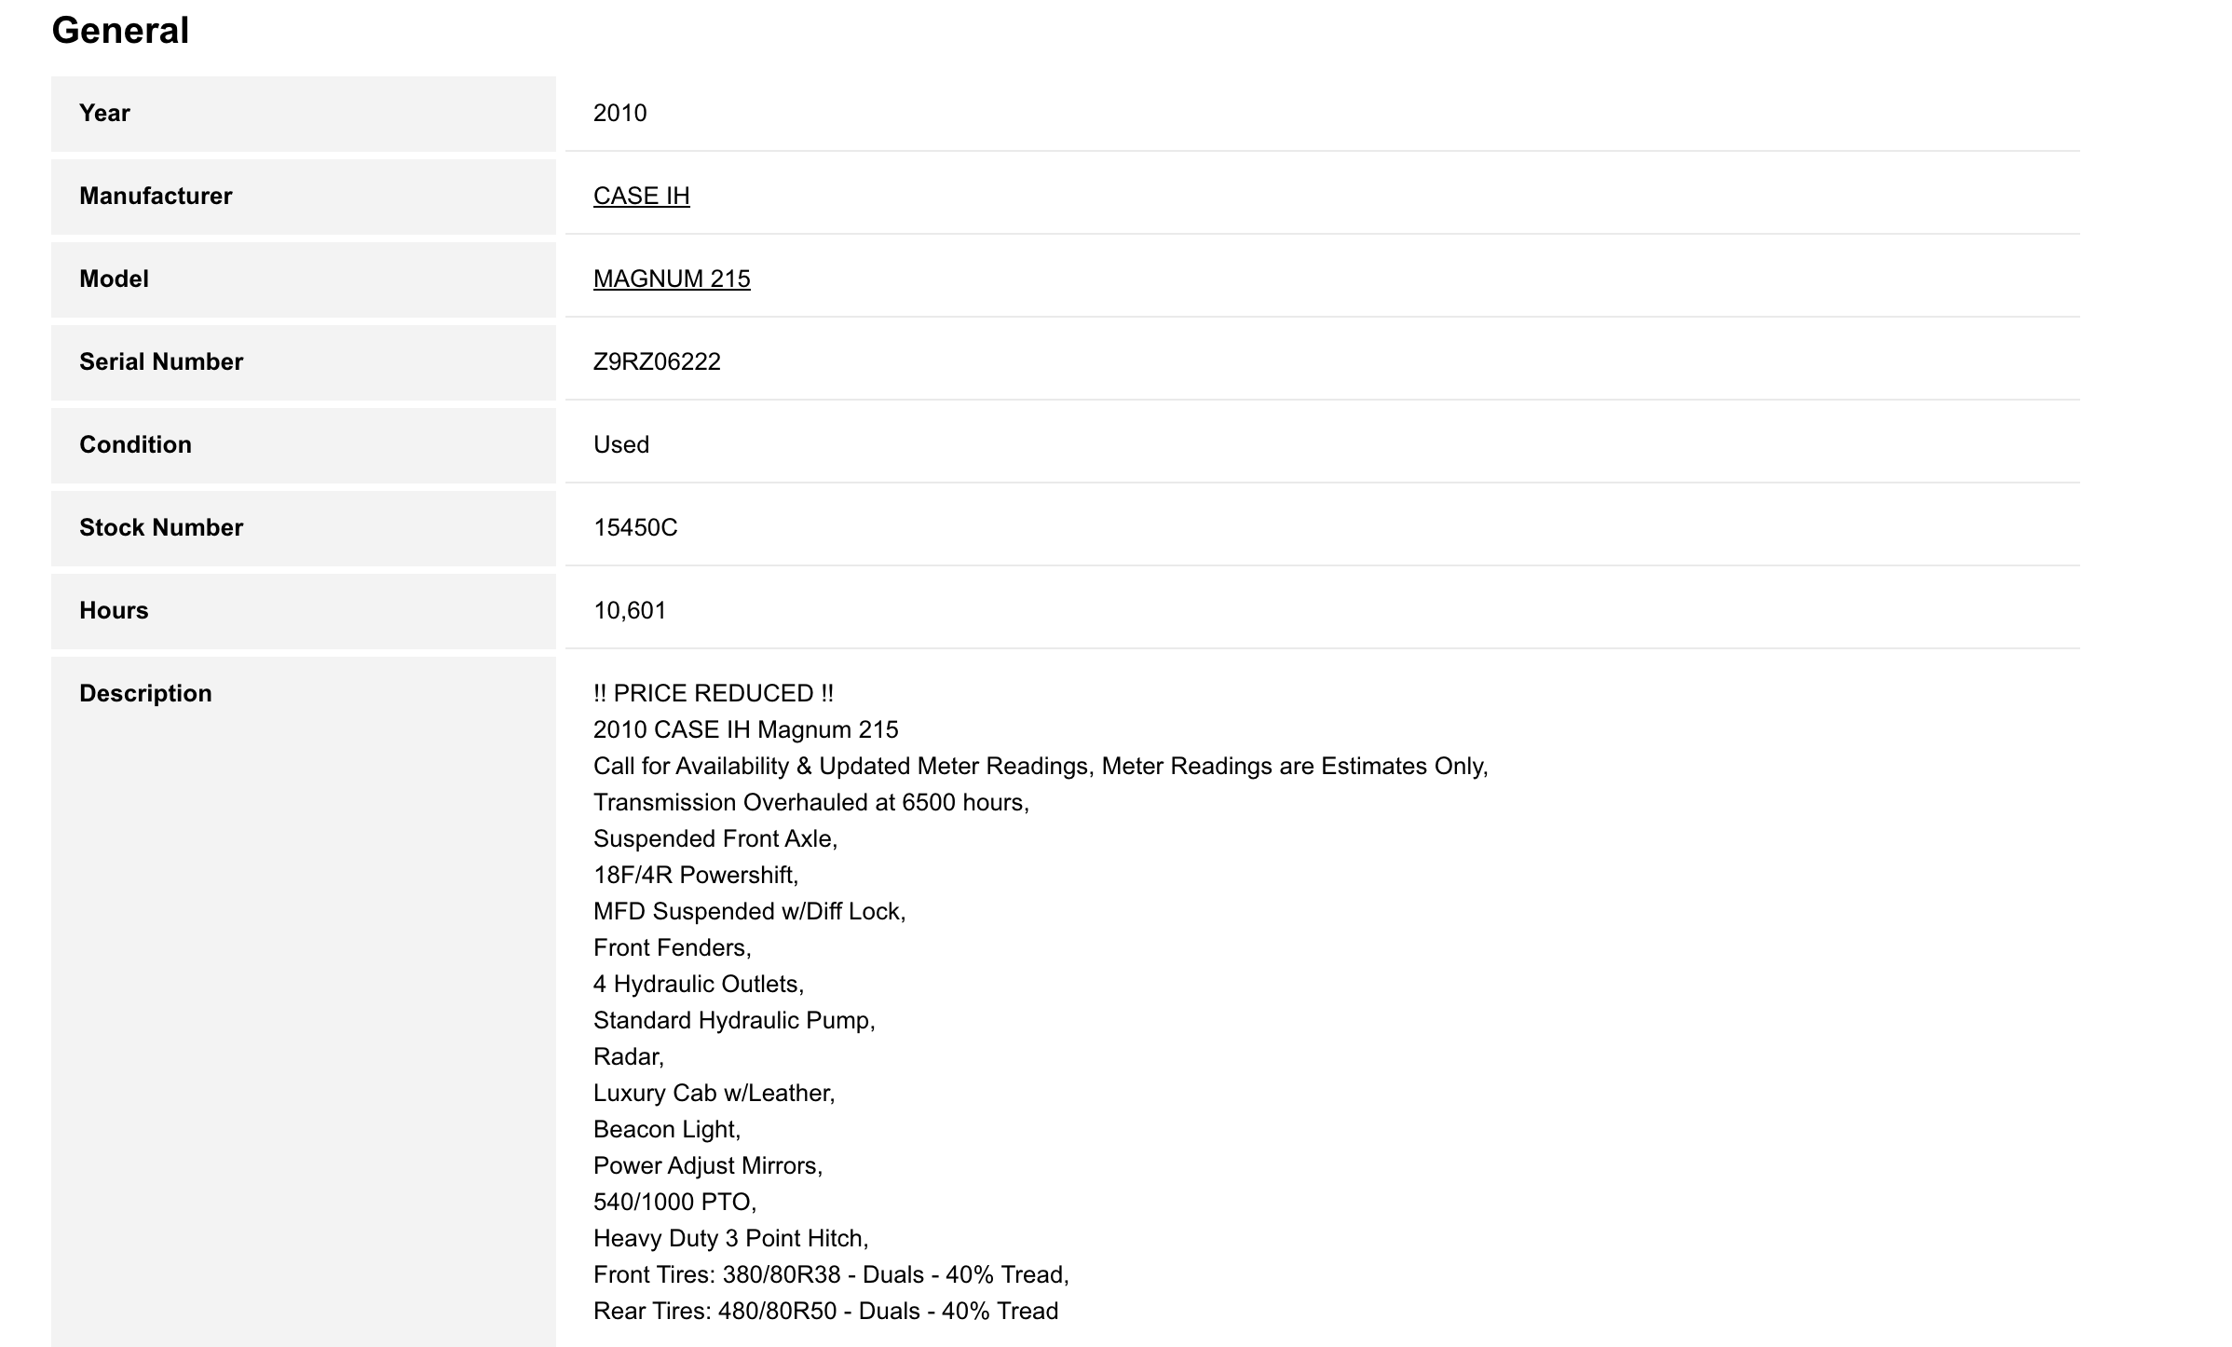
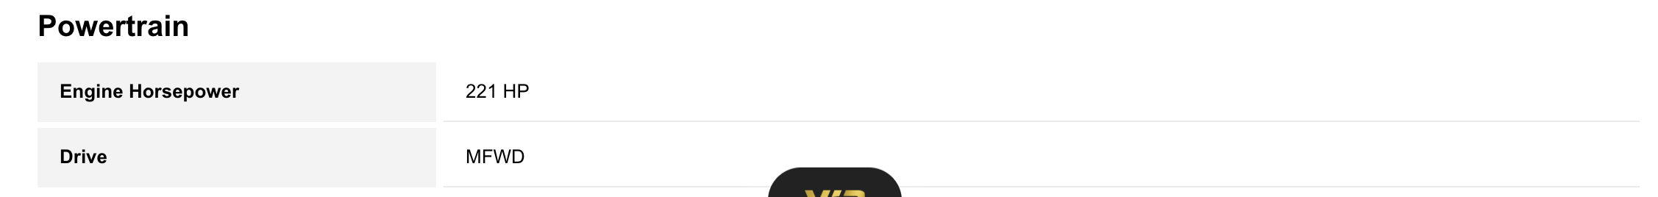
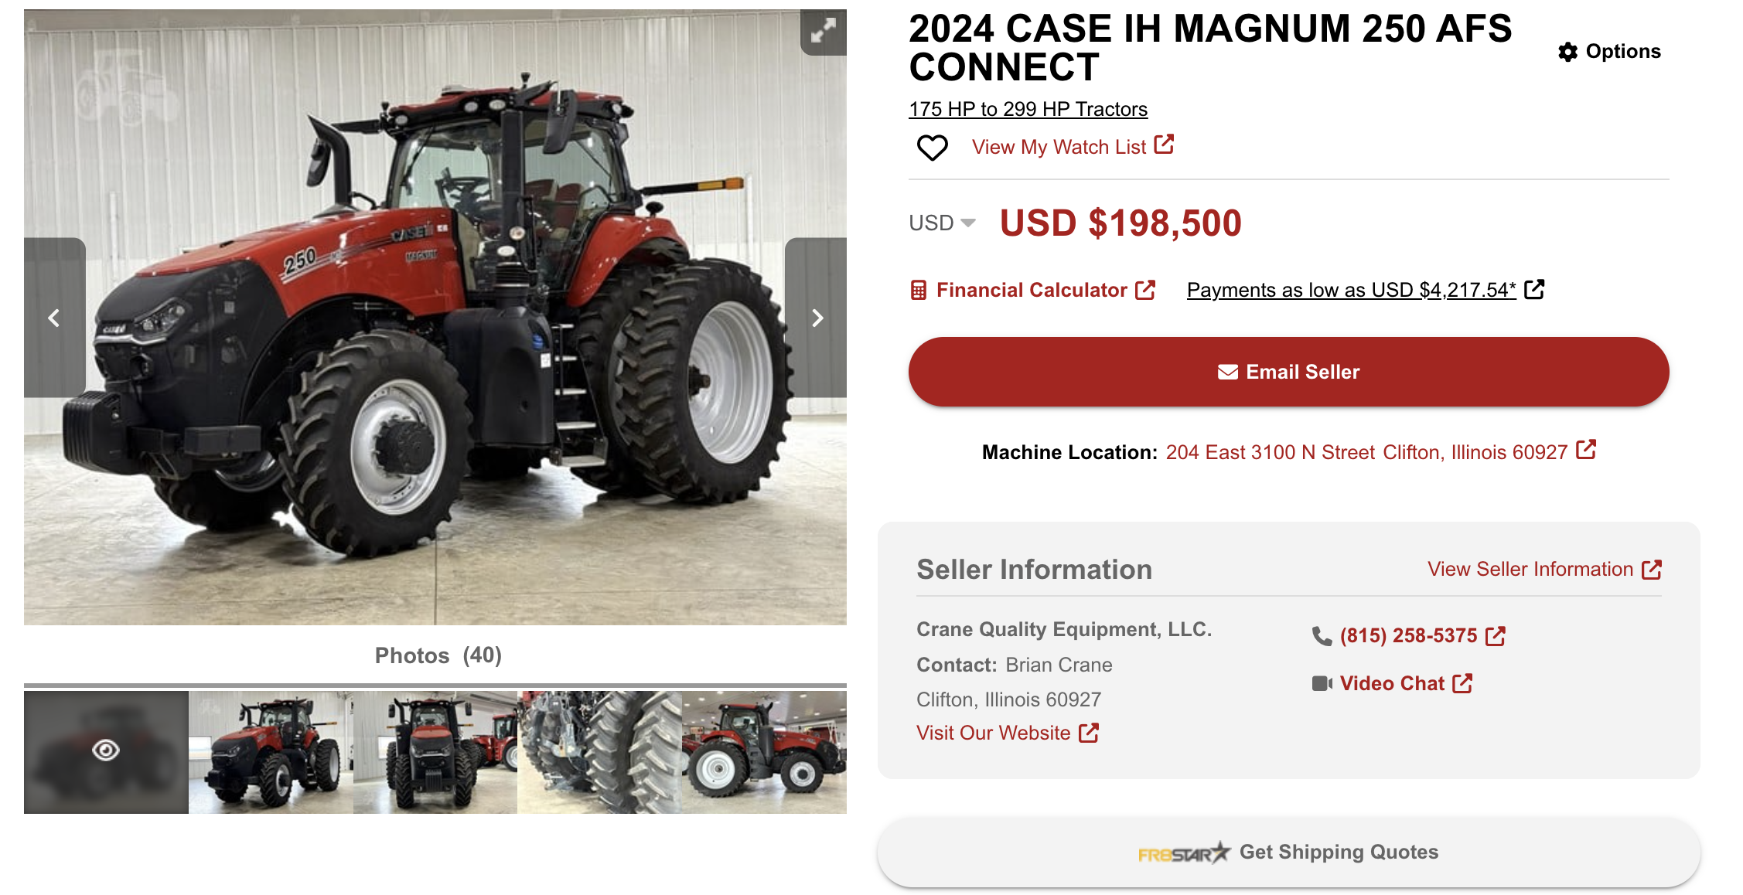
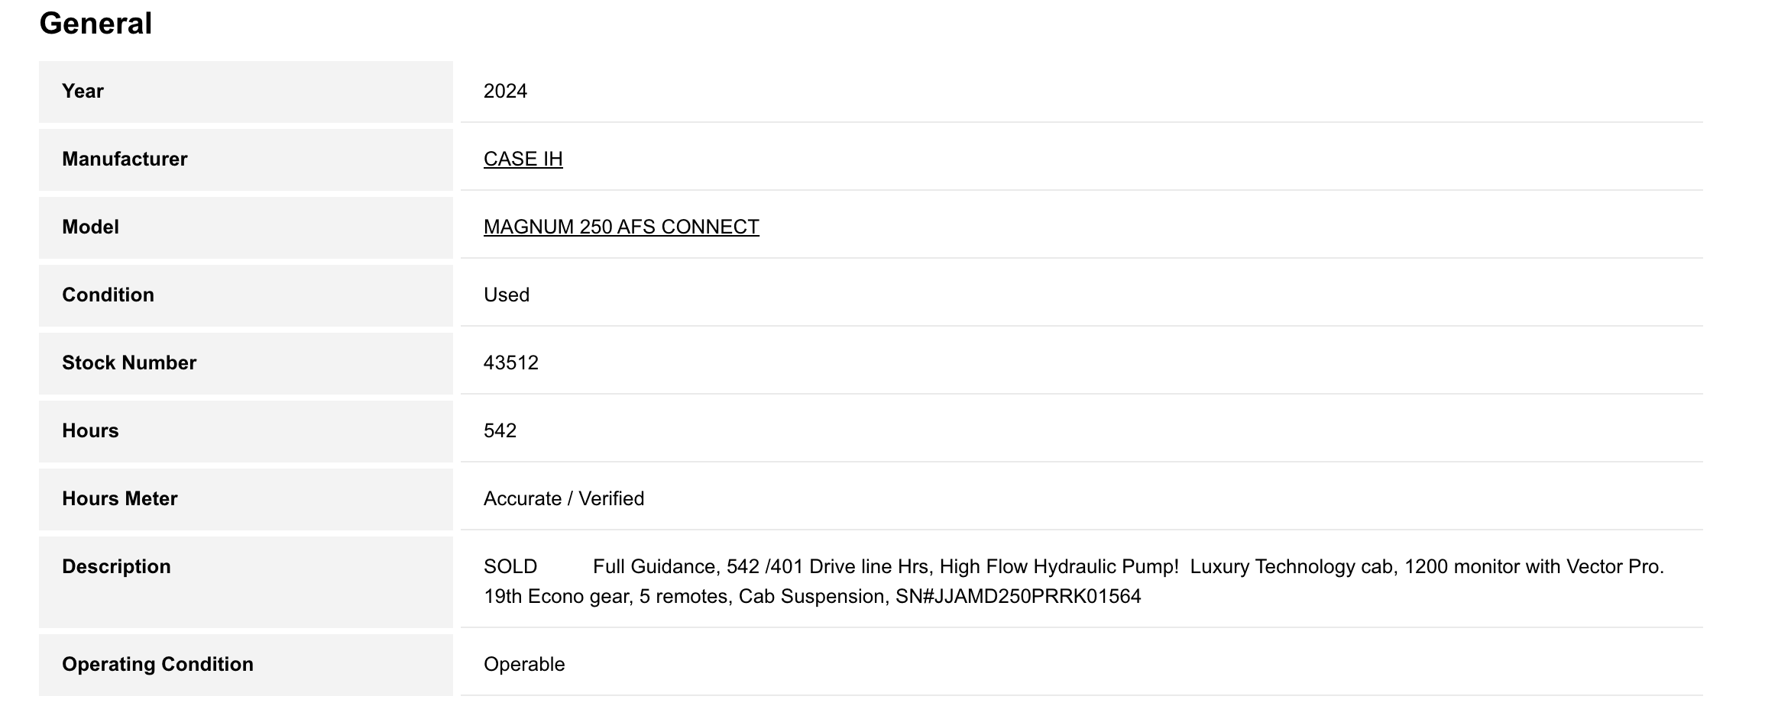
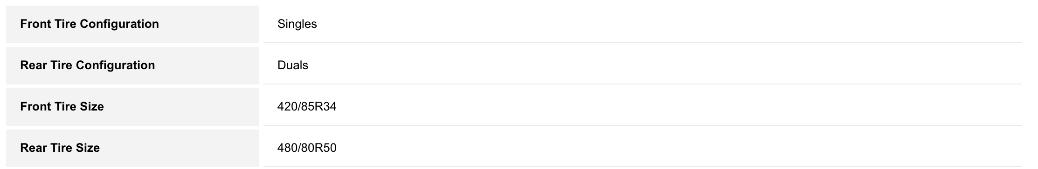

Project Metrics
Assumed utilization rate of 600 operating hours per year. We are also disregarding state sales tax. Because the transmission was rebuilt at 6,500 hours, transmission repair-cost assumptions are based on the post-rebuild component age rather than the tractor’s total 10,601 hours transmission , since the rebuild significantly reduces early-year failure risk.

1. Fuel Costs

This section is specifically difficult to establish an adequate annual cost. There are substantial number of variables that determine the fuel/hour rate for these machines. Such as workload, tires, machine age, and engine size.

The workload is a significant factor however since it is project dependent, it has less impact on the analysis. According to Virginia Tech Extension research by Grisso et al. (2004), diesel tractors typically consume fuel at rate defined by the equation of
$Q=\left(0.0434*\left(\frac{Job requiredHP}{MachineRatedHP}\right)+0.019\right)*(MachineRateHP)$
To establish a flexible annual job horsepower requirement variable we implemented a load scale for jobs which is typically between 0-150 horsepower, on average around 105 Hp, scale at 70%.
We attempted to find accurate machine age declining efficiently values but this is often case specific to maintenance, we choose to define a engine wear penalty to the rate for the 2010 model of 10%. New model efficiency bonus of 1% for the 2024 model.
Finding the current avg fuel price of Diesel to be $3.528 in Iowa, sourced by AAA’s statewide fuel price report for Iowa.

2. Routine Maintenance
- Tires
  - Hourly wearing rate
    - Radial Ag tires: 3,000 to 5,000 hours of use
    - Approx. 3500 hours per set of tires
  - Tire conditions
    - Magnum 215 (2010) :
      - Front Tires: 380/80R38 - Duals - 40% Tread
      - Rear Tires: 480/80R50 - Duals - 40% Tread
    - Magnum 250 (2024)
      - Front Tires: 420/85R34 - Singles - 40% Tread
      - Rear Tires: 480/80R50 - Duals - 40% Tread
  - Tire Prices
    - Magnum 215 (2010) :
      - Front Tires: 380/80R38 - $1200
      - Rear Tires: 480/80R50 - $1800
    - Magnum 250 (2024)
      - Front Tires: 420/85R34 - $1300
      - Rear Tires: 480/80R50 - $1800
- Oil change Standard Self-service (oil filter)
  - 250 Hour intervals
  - Magnum 215 (2010) : $180
  - Magnum 250 (2024): $ 200
- Fuel & Air Filters change :$125
  - 500 Hour intervals
- Hydraulic Maintenance: $200
  - 1000 Hour intervals
- Transmission Maintenance : $200
  - 750 Hour intervals
- Annual Maintenance
  - Magnum 215 (2010) : $500
  - Magnum 250 (2024): $250

3. Unscheduled Repairs
- Hours at time of purchase
  - Magnum 215 (2010) : 106101 Hours (4101 Hours after transmission rebuild)
  - Magnum 250 (2024) : 542 Hours

We that 200-300 hp range tractors transmissions typically have a 10000+ hour life. Therefore, even though the older 215 model has 4000+ miles it is less than half its expected life after rebuilding. We instead consider age directly in the annual costs
- Annual costs
  - Magnum 215 (2010) : $2000
    - This number is difficult to set but many sources indicate a rapid increase in annual repairs after 4000+ hours on a transmission in addition to the 10000+ hours on the machine itself
  - Magnum 250 (2024) : $500
    - Considering the early life reliability and warranty

4. Insurance
  - Annual rate 0.5% of Machine value

5. Depreciation (Tax)

Both machines fall in the 7 year double declining MACRS IRS tax category

6. Depreciation (Salvage) rate

We attempted 2 Methods in this section first we went with findings of an average Method 1 : Machine salvage depreciation rate of 8.3 % per year for both machines in addition to an additional 25% depreciation rate for the first year on the newer machine.

However, this does not accurately represent our Machines, as the Case 215 model has significantly less mechanical life left than the Case 250.

Method 2 :

This section is also quite difficult to produce an accurate rate of for the salvage value because for the new tractor, it initially loses a significant amount of value, but thereafter it holds value, while the older tractor aggressively loses value as its second transmission loses value later in its lifespan. We also recognized that both Models have salvage value floors, where the Magnum 250 could essentially have its transmission rebuilt at the floor, while the Magnum 215 would scrapped at its floor, due to it being on its second transmission. The main impact of the salvage value is the impact of the hourly use, while the age is secondary. It’s trivial to attempt to use sources predicting the rate because it is rather case by case specific. Therefor we produced our equation prediction model. Considering the remaining hours of the transmission, the final scraping value, annual usage, and the annual depreciation.
$$ΔS=Initial value-Scrap value$$

$H_{r}=\frac{(h)Annul hourly rate}{Transmission life Remaining (\max{hours-current hours)}}$

$$Y_{r}=Strict Annual depreciation (estamate)$$

$$S_{n}(n,h)=max⁡( S_{scrap}+ΔS(1-n\left(H_{r}+Y_{r}\right),S_{scrap})$$

  - Magnum 215 (2010) : Due to the starting age of 14 years, the overall 10,601 hours on the machine, and 4,101 hours on the second transmission, considering various estimates of scrapped models at 20+ years and 2,0000 machine hours. We found this model gives a more accurate estimate.
    - Most references estimate the scrap value on these machines to 10% of the initial value, estimated at $120,0000/10 = $12,000
    - We estimated on the low end for a strict age deprecation rate considering no operation at 3% per year. This estimate is difficult to find research values for; however, value of these machines hold value very well.
    - The main benefit is the method is incorporation of an annual hour operations depreciation; this truly shows more accurate estimates of an older machines life on a second transmission.
  - Magnum 250 (2024) :
    - The differences we had to consider for the Case 250 mode, was the first life transmission, so opposed to referring to an end of life “scrap value” we refer to an end of the first transmission salvage value”. Estimated with some findings at $40,000. As the transmission could be replaced.
    - Just as in Method 1 we had to include how the off the lot depreciation rate for Machine in year 1 would be much steeper, therefore we retained the first year 25% depreciation and referenced it as the initial value thereafter.

7. Trasmission life

To keep the comparison balanced, both tractors were evaluated with a 10-year economic life. This assumes each tractor would be replaced at the end of its 10-year ownership cycle. In reality, the newer Magnum 250 may have a longer physical life, which represents a qualitative advantage not captured in this constant-dollar AE comparison. To keep the comparison balanced, both tractors were evaluated with a 10-year economic life. This assumes each tractor would be replaced at the end of its 10-year ownership cycle. The newer Magnum 250 may have a longer physical life, which represents a qualitative advantage not captured in this constant-dollar AE comparison.

Final Economic Comparison and Conclusions

Based on the constant-dollar AE and PW analysis, as well as the after-tax cash flow proforma over a 10-year economic life considering both Salvage value depreciation methods, the 2010 Case IH Magnum 215 consistently outperforms the 2024 Case IH Magnum 250 AFS Connect in terms of life-cycle cost. The older Magnum 215 exhibits a significantly lower annual equivalent cost (both before and after tax) and lower present worth of total costs. Sensitivity analysis shows that the decision is most sensitive to annual operating hours specifically do the use of the Method 2 Salvage depreciation. However, this just make the analysis more difficult because the analysis is done on the 10-year economic life cycle, which would infer a machine repurchase at year 8, due to operation hours on the second transmission, which was not considered. Diesel fuel price also plays a significant role in the AEC after tax. However, across all tested scenarios the older tractor remains the lower-cost alternative. Under the stated assumptions, the Magnum 215 is the economically preferred option for this application. Because this analysis does not consider the moder technology in the newer machines, which often provides lower labor hours and more accurate grid mapping.

AI Disclosure Statement

Generative AI tools, specifically ChatGPT, were used in this project for brainstorming, clarifying methodological steps, and locating supporting information sources related to fuel efficiency, maintenance intervals, depreciation conventions, and tractor specifications. AI assistance was also used to help refine the organization and clarity of certain written sections.

No AI-generated numerical outputs, economic calculations, tax values, or model results were accepted without independent verification. All quantitative values—including fuel estimates, maintenance costs, depreciation schedules, salvage modeling, and after-tax cash flow calculations—were manually reviewed, validated, and recalculated using Excel and authoritative sources.

No prohibited use of AI occurred: the analysis, formulas, proformas, and final economic decisions were performed independently by the project team.

REFERENCE SECTION

Market Quotes

Older Model — 2010 Case IH Magnum 215

Source: TractorHouse – Central Plains Equipment (Goodland, KS)
Price: $56,320
Hours: 10,601
Condition Notes: Transmission overhauled at 6,500 hours; suspended front axle; 18F/4R powershift transmission; mechanical front drive (MFD) with differential lock; luxury leather cab; radar; dual rear and front tires (40% tread); heavy-duty 3-point hitch.
Listing URL:
https://www.tractorhouse.com/listing/for-sale/238623741/2010-case-ih-magnum-215-175-hp-to-299-hp-tractors

New Model — 2024 Case IH Magnum 250 AFS Connect

Source: TractorHouse – Crane Quality Equipment (Clifton, IL)
Price: $198,500
Hours: 542
Condition Notes: Factory-integrated guidance; high-flow hydraulic pump; luxury technology cab; 1200-series Pro 1200 monitor with Vector Pro receiver; 19th Econo gear package; cab suspension; five rear remotes; low verified hours.
Listing URL:
https://www.tractorhouse.com/listing/for-sale/249280555/2024-case-ih-magnum-250-afs-connect-175-hp-to-299-hp-tractors

Tire Operation Hours

CEAT Specialty. (n.d.). How long should your farm tires last?
https://www.ceatspecialty.com/blog/tire-advice/how-long-should-your-farm-tires-last

Fuel Efficiency Rate

Grisso, R., Vaughan, D., & Perumpral, J. (2004). Predicting tractor diesel fuel consumption. Virginia Cooperative Extension Publication 442-073, Virginia Tech.
https://vtechworks.lib.vt.edu/bitstreams/a315bc0d-deb2-46c0-98b3-8bc555861211/download

Fuel Price (Iowa Diesel)

AAA. (2025). Iowa average diesel fuel prices. AAA Gas Prices.
https://gasprices.aaa.com/?state=IA

Tire Prices

Specs: 480/80R50 — SimpleTire.
https://simpletire.com/tire-sizes/480-80r50

Specs: 380/80R38 — SimpleTire.
https://simpletire.com/tire-sizes/380-80r38

Specs: 420/85R34 — Nebraska Tire.
https://www.nebraskatire.com/product/4613

Oil Change Intervals

CASE IH. (n.d.). Magnum Series 175–275 PTO HP Brochure.
https://mapexusa.com/documents/Magnum_BROCHURE_175-275_PTO_HP.pdf

Engine Oil Capacity

Case IH Magnum 215 — RitchieSpecs.
https://www.ritchiespecs.com/model/case-ih-magnum-215-4wd-tractor

Case IH Magnum 250 — Humber College (Service Manual excerpt).
https://humber.ca/fcls/docs/case/CASE_IH_MAGNUM_250_AFS_CONNECT_Service_Manual

Oil Change Pricing

STP Diesel. (n.d.). Factors that affect the cost of a diesel oil change.
https://stpdiesel.com/factors-thats-affect-how-much-a-diesel-oil-change-co

Cropilots. (n.d.). Farm tractor maintenance costs.
https://cropilots.com/farm-tractor-maintenance-costs

Fuel & Air Filter Cost Expectations

Cropilots. (n.d.). Farm tractor maintenance costs: Typical service intervals and expenses.
https://cropilots.com/farm-tractor-maintenance-costs

Air filter pricing — Tractor Supply Company.
https://www.tractorsupply.com/tsc/search/tractor%20air%20filter

Hydraulic Fluid & Filter Intervals

Hydraulic fluid change — Cropilots.
https://cropilots.com/change-hydraulic-fluid

Hydraulic/transmission filter intervals — Koenig Equipment.
https://support.koenigequipment.com/how-often-should-i-replace-hydraulic-filters-on-my-equipment

Routine Maintenance & Consumables

University of Nebraska–Lincoln Extension. (n.d.). Estimating farm machinery costs (EC823).
https://extensionpublications.unl.edu/assets/html/ec823/build/ec823.htm

Iowa State University Extension. (2024). Estimating farm machinery repair costs (A3-29).
https://www.extension.iastate.edu/agdm/crops/html/a3-29.html

Insurance Rate

Iowa State University Extension. (n.d.). Ag Decision Maker A3-29: Machinery costs.
https://www.extension.iastate.edu/agdm/crops/html/a3-29.html

Transmission Life Expectancy

Farm Progress. (n.d.). How long should a tractor last?
https://www.farmprogress.com/machinery/how-long-should-tractor-last

MACRS Tax Depreciation

IRS. (2024). Publication 946 — Appendix A: Table A-1 (MACRS Percentages).
https://www.irs.gov/pub/irs-pdf/p946.pdf

Tractor Depreciation & Salvage Value

Daninger, N. (2017). Depreciation in the U.S. used tractor market. Purdue University.

ASABE (American Society of Agricultural and Biological Engineers). Standard D497.7 — Agricultural Machinery Management Data.
“Salvage value is commonly assumed to be 10% of the new list price.”

